IMPORTANT NOTE: I use cyber bullying as a topic throughout this paper to provide you with examples, please do not assume you have to write a paper on cyberbullying. Also, if you do decide to write a paper on cyber bullying, please know that I made up these examples. My example (argument/research finding/discussion/implications are not actually based upon the literature. Some points I made with my cyberbullying example could be true, but none of my example is researched based. My goal was only to provide you with a model for how to address this assignment.

Literature Review: Insert Topic (e.g., Cyber Bullying)
Ima Strong Student
Section CNQ
Lamar University

Title of Your Report (which is “Literature Review: insert topic (e.g., cyber bullying)
Write your introduction here in paragraph form. Introduce the paper and what you will be discussing in 5-8 sentences. With this cyberbullying example, I would say what it is, why it is a problem, state our responsibility as counselors to address it, then make mention of one or two of my main implications for practice (e.g., recommendations of what counselors can do to address cyberbullying). Side note: you will likely need between 8-14 pages of writing in addition to you cover page and reference page. In my opinion, between 10-12 pages is what you will optimally need to address all assignment prompts and rubric points. Keep in mind you need 10 references and they must be no older than 10 years. See the assignment instructions and rubric for all requirements
Background of Topic Area (approximately 2 pages)
Describe the topic and define important terms and areas important to the field of counseling. In this section, I would define bullying, emotional bullying, cyberbullying and the ways cyber buying occurs (Use references).
Rational
Explain your philosophical position and rationale for the review. Include a problem statement or any guiding questions for your search. For cyber bullying, I would state why cyber bullying is bad, talk about the prevalence of cyber bullying, talk about the negative effects of it, talk about our ethical responsibility as counselors to address it. I would also mention some of the ways counselors attempt to address cyberbullying, and explain why these attempts have been unsuccessful. Hence, my problem statement is that cyber bullying is growing, we are ethically responsible to address it, however, many of the current intervention have been unsuccessful in addressing the problem. Here your goal is to make a distinct and succinct argument that you will expand up in the results section and discussion.
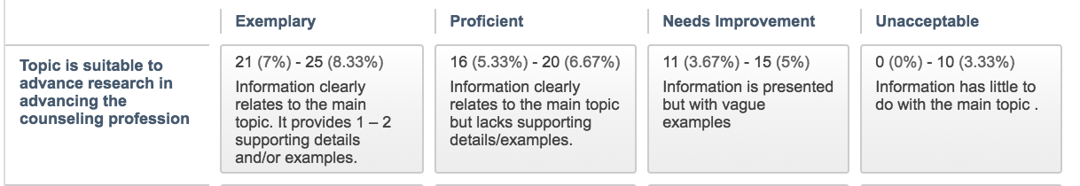
Research Designs and Importance
Discuss the importance using this research to advance the counseling profession. Include a description of the type of research (quantitative, qualitative, and mixed methods) that you discovered in your search from Assignment 1 and throughout the course. In other words, organize all of your research article by their designs. For example, after discussion the importance of using research to advance the counseling profession, you might organize the articles you are using for this paper by their research designs and introduce them to the reader by there design e.g., here are the quant articles; here are the qual articles; here are the mixed methods articles. Within the quant articles here are the ones for experimental designs, this is what an experimental design is. Here are the ones for non-experimental design, this is what a non-exp design is, within the qual articles here are the phenomenology/grounded theory articles and here is a short description of these designs…etc. Then I might discuss the topics that each research design explored.
Also, discuss how you located the articles with your electronic search in the database like you did in assignment week 1. Regarding the next part of this rubric point “overview of the articles based upon context, sample, method, you will discuss the method above, but you will save discussing the article sample, context, and findings for the results section.
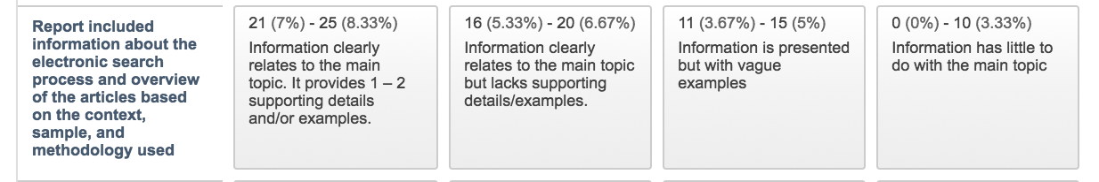
Results (approximately 4 pages)
Group the articles collected by identifying any major themes that stand out to address your problem statement. For example, remember that rational we just wrote? Let’s use that to guide our level two headers. In this section, right here prior to the below you will have 3 sentences to introduce the topics you will discuss below.
Prevalence of cyber bullying
It is important to note the type of research methods used in each article selected (e.g., qualitative, quantitative, single-case designs, action research, and outcome-based research). Explain your understanding of the findings of these articles based on the context, sample, and methodology used. For example, lets say I found 3 non-experimental cross sectional or longitudinal designs that attempted to determine how prevalent cyber bullying is. I would describe the research design, the sample, the procedures use, then I would share the findings of how prevalent it is according to study A. Now I will repeat this pattern for my remaining two articles that I found that address prevalence. I might then close with a sentence stating how cyber bullying is growing as the use of social media increase. Then I will have a transition sentence indicating that this growth is concerning considering the short and long term consequences of cyber bullying for students.
Short Term Consequences
Here I will follow the same exact pattern that I just did to talk about the research for the prevalence studies above. Describe the research design, the sample, the procedures use, then I would share the findings. Then do it again for the next article.
Long Term Consequences
Here I will follow the same exact pattern that I just did to talk about the research for the prevalence studies above. Describe the research design, the sample, the procedures use, then I would share the findings. Then do it again for the next article.
Interventions and Programs
Here I will once again follow the same patterns above to discuss the studies I found that attempted to assess cyber bullying interventions. I will then use the above findings to guide my discussion and implication sections. In this example (that I am making up from my head…not the actual literature on cyberbullying), I noticed that just about all the interventions that studies were conducted on were unsuccessful (or not successful enough), so I would talk about why they were unsuccessful.
Research Limitations
Include the limitations of any information you select from the sources and cultural considerations. Discuss the cultural implications and limitations and/or any legal/ethical considerations regarding the research examined—especially pertaining to any specific population you foresee as part of your future counseling work. In this section, for my cyberbullying example, I will specifically identify limitations of the studies I previously mentioned in this findings section. Hint: look at the limitations section of each study for ideas. Make sure to also address any culturally related limitations of the research articles you used. I would discuss the cultural implications (X study only sampled girls) (boy and girls may experience cyberbullying differently) and limitations (small sample size in the X non-experimental research design) and/or any legal/ethical considerations (X study did an experimental design and treated one group of students with cyberbullying issues and not another group…this was unethical to do) regarding the research examined.
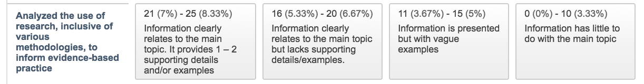
This above rubric point can be fulfilled in your limitations section.
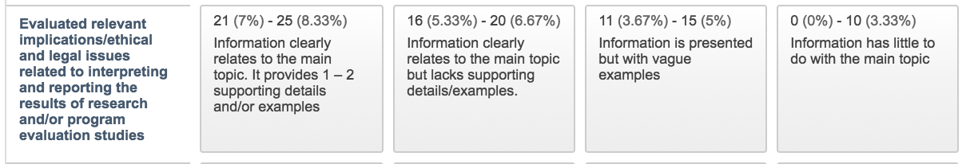
This above rubric point I also completed within your limitations section.
This above rubric points is completed throughout your results section. You will have already discussed how you found these articles with your electronic searchers earlier in the paper, so you do not need to do it again here. As you are notices, different parts of the rubric points can be accomplished throughout different parts of your paper.
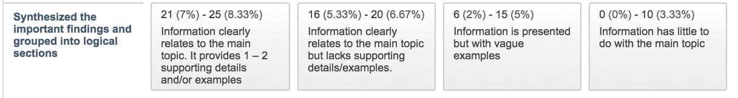
This above rubric points is completed throughout your results section. You are organizing the findings sections by sub topics. See my examples above in this results section.
Discussion (approximately 3 pages)
Use references to back up the points you make throughout this discussion section. Provide a summary of the state of research as it relates to your topic of interest. Essentially, in this section my goals is to help the reader make sense of all of the research I talked about earlier. For example, I might have the following sections and make the following points.
Ethical Responsibility
I might say that considering the damaging short and long term effects of cyberbullying school counselors have a responsibility to address it. For example…. Now I will state a bunch of related ASCA ethical codes and how they connect to our responsibility to protect our students.
Intervention Integration
Discuss the ways you can use the research articles selected to inform evidence-based practice. In this section I would discuss how previous interventions were not successful because they were not integrated with comprehensive school counseling programs (CSCP)..(I am just making this up off the top of my head as an example). Then I would talk about how to integrate cyberbullying interventions with a CSCP.
Culturally Responsive Intervention
Discuss the ways you can use the research articles selected to inform evidence-based practice. Here I could point out how the unsuccessful interventions were not culturally responsive. I then would discuss how to implement culturally responsive interventions.
Stakeholders Involvement
Discuss the ways you can use the research articles selected to inform evidence-based practice. Here I could point out how not enough stakeholders were involved and who should be involved e.g., parents/teachers) and how to involve stakeholders.
Implications (approximately 3 pages)
This is the section where I now make specific recommendation for school counselors. These should be logical recommendation that you are making up based upon what you figured out school counselors need to do in order to address your topic (e.g., cyberbullying).
Training
Here I might talk about how school counselors need to be trained in integrating cyberbullying interventions with CSCP, their ethical responsibilities related to cyberbullying, and how to implement culturally responsive interventions.
Stakeholder Education
Here I might make some more recommendation on how to involve stakeholders with the interventions and what type of information we might need to train them on related to cyberbullying and social media use to be effective with their involvement
Student Education
Here I could talk about what we need to train students on to safely and responsibility use the internet/social media.
The above rubric point is fulfilled throughout the implications section.
The above rubric point is fulfilled throughout the implications section.
Future Research
What future research might you recommend in your topic area and what methodology might help you address your inquiry? In other words you will have to come up with ideas for studies that should be done to gain more information on certain areas of interest related to your topic.
Conclusion
Summarize you main points in this implications sections. Each of your implications (e.g., are a type of conclusion your have come to, so put them all together in a succinct 7-10 sentences paragraph and spell out for the reader how these conclusions are directly addressing your problem statement that you discussed in your rational.
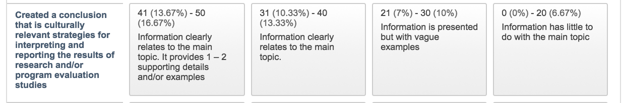
The above rubric point is addressed throughout your implications section.
Reflection
Identify any trends in your review. Is there any type of methodology that was difficult to locate? Discuss your learning experience in this course and your preparedness for using research in your practice as a professional counselor.
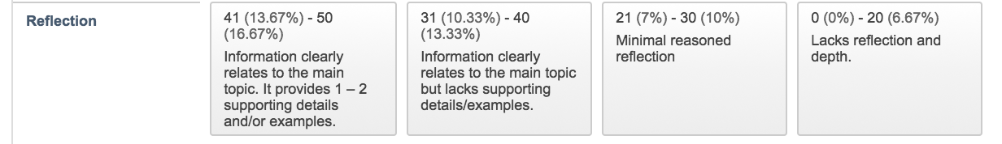

Make sure to also address the below Rubric Points throughout the paper.
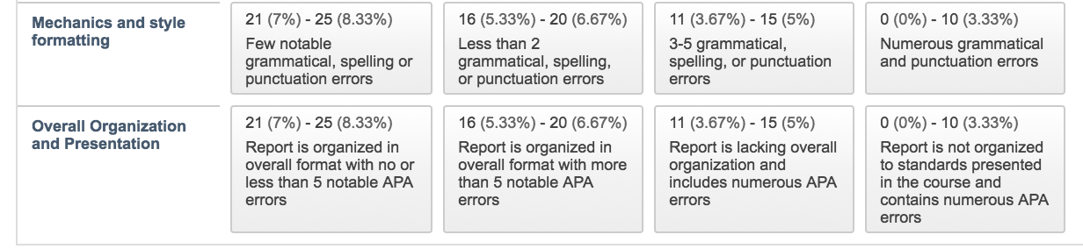

References
10 or more references. All references must have been published within the last 10 years. Points will be deducted from the Mechanics and style section of the rubric for not following these directions.

